 | International Civil Aviation Organization  WORKING PAPER
  ACP WG-F/25 WP 14
ACP Working Group F (Frequency)

25th meeting of WG-F, Dakar, Senegal 10 – 14 October 2011
Agenda Item 6: | Any Other Business
Update on Off-Board Communications
for Vehicle Health Management – Airport Surface

(Presented by Robert J. Kerczewski, U.S. National Aeronautics and Space Administration)

SUMMARY
At the 21st meeting of Working Group F, NASA presented results on the analysis of off-board communications requirements to support future aircraft vehicle health management (VHM) systems (ACP-WGF21-WP23), focusing on an assessment of in-flight off-board data communications transmission requirements. Two recent research efforts supported by NASA have resulted in further development of VHM systems, known as Vehicle Level Reasoning System (VLRS). One of these efforts has provided an estimate of potential off-board VHM data transmission requirements for the airport surface, that is, after the aircraft has landed. An analysis of potential airport surface data requirements based on the VLRS research is presented.

ACTION
The meeting is requested to note the airport surface data communications requirements for future VHM systems, and consider the potential requirement for aviation spectrum to support this requirement.

1. Background

1.1 NASA’s Aviation Safety Program has continued research and development focused on reducing the impact of adverse events during flight, through the development of vehicle health sensors to detect and monitor the health of critical aircraft systems, as well as the algorithms that will interpret the resulting sensor data to determine the health status of the aircraft. This work was presented at ACP WGF-21 in Working Paper 23. The focus of ACP-WGF21-WP23 was an assessment of the potential requirements for in-flight downlink of vehicle health management data.
Since that time, NASA has sponsored development work focused on the implementation and use of algorithms designed to interpret the collected vehicle health sensor data. The system is referred to as Vehicle Level Reasoning System (VLRS). Two NASA Research Announcements awards enabled two industry-led teams to develop approaches to the integration of vehicle sensor data and data processing algorithms to create vehicle level health management systems. The results of one of these VLRS projects enable an estimate of the volume of data required to be downloaded on the airport surface to support the VHM system. The discussion below presents this estimate and describes its derivation.
2. Discussion
2.1 Two NASA Research Announcement awards were made for VLRS system research and development. Honeywell International, Inc, is developing the Vehicle Integrated Prognostic Reasoner (VIPR). VIPR consists of an on-board system analyzing the inputs from various aircraft sensors, as well as past history of the aircraft health [1, 2]. The results of this work to date have provided a basis for Honeywell to estimate that the VIPR system will produce 2.76 MB of VHM per flight hour that would be downloaded upon aircraft arrival to enable data archiving and application of data mining to assess long term vehicle health trends across aircraft fleets.
2.2 The Boeing Co. received the other NASA VLRS award. The Boeing system relies on the in-flight off-board communication of VHM data for processing on the ground. The progress to data has not yet provided sufficient additional data to revise the in-flight off-board data requirements presented in ACP-WGF21-WP23. The data rate requirement of 742.4 kbps was obtained in that analysis, with the majority (675.4 kbps) of this amount is required in real time or near-real time, that is, with very low latency and high availability.
2.3 The figure of 2.76 MB per flight hours allows a maximum airport surface data rate to be estimated. The estimate is dependent on the volume of flight operations at a given airport. We analyzed a typical medium sized airport, Cleveland Hopkins International Airport (CLE) and a very large airport, Chicago O’Hare International Airport (ORD). Using the published Monday flight schedule for CLE (June, 2010) and ETMS data for ORD (Monday, 14 June, 2010), the length in time of the arriving flight was tabulated for each 10 minute increment throughout the day. This provided a table of total flight arrival minutes (the total of the flight times for all flights arriving within a particular 10 minute increment). The total volume of VHM data to be downloaded during each 10 minute increment is calculated using the 2.76 MB per flight hour figure. Figures 1 and 2 show these results.
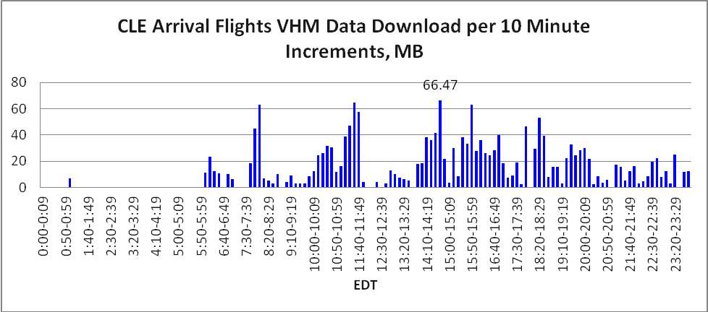
Figure 1 – Total VHM Data Download Requirements for CLE, MB per 10 minute Increment, June 2010
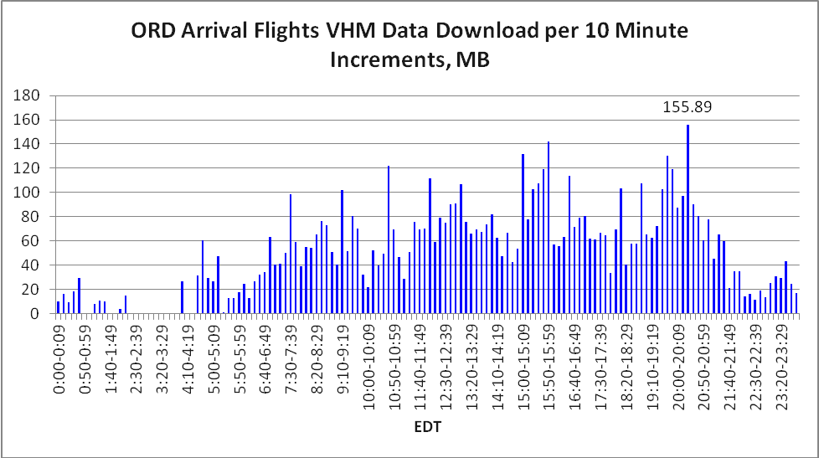
Figure 2 – Total VHM Data Download Requirements for ORD, MB per 10 minute Increment, June 2010
2.4 The peak airport surface data rate that must be supported for the VHM system based on the VIPR design is calculated by dividing the peak volume by 600 seconds, multiplied by 8 bits per byte. For CLE, 66.47MB X 8/600 = 886.3 kbps. For ORD, 155.89MB X 8/600 = 2078.5 kbps. This peak data rate does not include network/protocol overhead or security overhead, and is based on June, 2010 traffic levels.
3. Proposed Action
3.1 The meeting is invited to take note of the emerging requirements for vehicle health management data transmission from aircraft on the airport surface. Recent research results indicate that medium size airports will required to support a peak data rate of approximately 1 Mbps, while large airports will be required to support data rates greater than 2 Mbps. This requirement for airport surface communications will significantly impact spectrum requirements for airport surface communications systems, and may require additional spectrum allocations for airport surface communications.

4. References

1] Vehicle Integrated Prognostic Reasoner, https://c3.nasa.gov/dashlink/static/media/other/avsafe_vipr-2011.pdf.

2] Vehicle Integrated Prognostic Reasoner (VIPR) 2010 Annual Final Report, NASA Contractor Report NASA/CR-2011-217147, http://ntrs.nasa.gov/archive/nasa/casi.ntrs.nasa.gov/20110012171_2011012606.pdf

