ICAO NSP WG1&2/WP5

NAVIGATION SYSTEMS PANEL (NSP)

Working Group 1 and Workin Group 2 meetings
Montreal, 11 to 21 September 2005

WG1 Agenda Item 6.a: Spectrum – WRC-07 Agenda Items 1.5 and 1.6

Interference Susceptibilities of Aeronautical Systems
Operating in the 960-1215 MHz Band
Application to the Compatibility Analysis of the Future Communication System

Presented by Michel Calvet

Prepared by Frédéric Bastide (Sofréavia)

SUMMARY
In the frame of the WRC-07 Agenda Item 1.6, a candidate frequency band to receive the future Air/Ground aeronautical communication system (FCS) is the 960-1215 MHz ARNS band. In the course of the selection process of the most adequate technology for the FCS, it is necessary to analyze electromagnetic compatibility with the current and future aeronautical systems (DME, SSR, UAT, GNSS etc…) operating within this frequency band. This paper presents a preliminary study which provides known susceptibilities of receivers used by the above systems according to reference documents (ICAO SARPs, EUROCAE and RTCA MOPSs). Those susceptibilities will help design the FCS even if some of them are missing. These latter figures are pointed out in this paper as well as possible ways to determine them. This paper also provides directions on the way to reduce unwanted emissions from the FCS in order to ease its possible introduction in the already heavily used 960-1215 MHz frequency band.

Introduction
Under agenda item 1.6 of the next ITU WRC-07, a new aeronautical Air/Ground communication system is envisioned in the lower part of the 960-1215 MHz frequency band. This band is an ARNS band that is reserved for aeronautical navigation services on a primary basis as stated in ITU Radio Regulation. As explained in the ICAO position to the next ITU WRC-07 [1], this future communication system (FCS) shall not cause harmful interference to the existing systems nor claim protection from them.

As a consequence, a compatibility analysis between the aeronautical systems operating in the 960-1215 MHz band and the FCS system must be performed from the initial stages. In the course of this analysis, the already known susceptibilities of the current systems must be listed. This paper provides the outcomes of this analysis. In the next step, those susceptibilities, along with additional ones that are unknown and so still to be determined, will allow to assess an “envelope” in which the candidate signal characteristics must be constrained. Those characteristics are, amongst others, its transmitted power, modulation, spectrum shape and temporal structure (e.g. continuous or bursted).

Section 2 of this paper will describe the existing aeronautical systems operating in the 960-1215 MHz ARNS frequency band and also provide the known susceptibilities according to available reference documents (ICAO SARPs, EUROCAE and RTCA MOPSs). Section 3 addresses the initial compatibility analysis. Eventually, conclusions are drawn.

Existing Systems

Introduction
The 960-1215 MHz band is an ARNS band that is reserved and protected for aeronautical navigation services. This band is already used by many civil aeronautical systems: DME, SSR, GNSS signals etc. There is also the Universal Access Transceiver (UAT) datalink system that will operate in the future on the 978 MHz frequency. Military systems also operate within this band. Those are the aeronautical TACAN system and the Link 16 datalink. Operation of both of them is regulated on a national basis through civil/military agreement. All the systems introduced above are briefly described in subsequent sections and the susceptibilities provided by various reference documents are indicated.

In order to get an overview of the frequency compatibility issue, the various frequency allocations in the 960-1215 MHz frequency band are depicted in Figure 1.

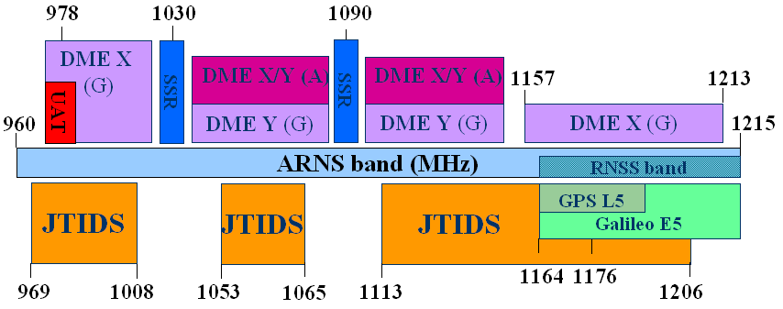
- Overview of the 960-1215 MHz ARNS Band Frequency Allocations

Note: (A) and (G) denote respectively airborne and ground DME transmissions in X and Y modes.

Aeronautical Civil Systems

Distance Measuring Equipment (DME)
The DME system is an ICAO standardized pulse-ranging system for aircrafts. It allows for the determination of the slant range between an aircraft and known ground locations. A DME ground station may be combined with a collocated VOR, ILS, MLS or TACAN system to form a single facility. When this is done, the DME frequency is paired with the VOR, ILS, MLS or TACAN frequency according to ICAO Annex 10 [ICAOVol1].
The DME onboard interrogator obtains a distance measurement by transmitting pulse pairs and waiting for pulse pairs replies from the ground beacon. Each pulse pair is returned by the transponder after a fixed delay. Based on the measured propagation delay, the aircraft interrogator equipment calculates the distance (slant range) from the transponder to its current location. Pulses have a half-amplitude duration of 3.5 μs and pulse pair spacing depends on the mode. There are four DME modes (X, Y, W and Z) but currently modes W and Z are not used.
DME frequencies are spaced in 1 MHz increments throughout the 962 to 1213 MHz band. Interrogation frequencies are contained within the band 1025 to 1150 MHz, and reply frequencies from the beacon are on paired channels located either 63 MHz below or above the corresponding interrogation frequency. Figure 2 depicts the standard DME/TACAN channel plan. Note that secondary suveillance radar (SSR) and TCAS operate on frequencies in the 1030±10 MHz and 1090±10 MHz ranges, so DME channels lying within those ranges, and the corresponding ground reply frequencies are not used. Note this frequency plan is also valid for the TACAN system that is described in section 2.3.1.

- Standard DME/TACAN Channel Plan

Relevant airborne and on-ground DME receiver susceptibilities are summarized in the next table.

DME | Airborne Receiver | On-ground Receiver
Operating frequency range  (MHz) | X mode: 962-1024 & 1151-1213  Y mode: 1025-1087 & 1088-1150 | X-Y mode:  1025-1087 & 1088-1150
Typical bandwidth (MHz) | 6 | 6
Sensitivity | -82 dBm at the Rx. input based on accuracy, search and track requirements (ICAO Annex 10, Vol. I, Attachment C, section 7.2.1.1) | -91 dBm for en-route at the Rx. input based on 70% reply efficiency (EUROCAE ED-57)
Sensitivity | -83 dBm at the Rx. input based on accuracy, search and track requirements (EUROCAE ED-54/RTCA DO-189)
Known susceptibilities | Co-channel DME signal (1/2)  (same frequency and same pulse pair spacing). Accuracy requirements shall be met in presence of 3600 ppps with a minimum C/I=8 dB (Annex 10, Vol. I, section 3.5.5.3.4.1 & EUROCAE ED-54) | Continuous Wave signal (CW)  Reply efficiency shall remain greater than 70% in presence of in-band continuous CW with a minimum C/I=10 dB. (EUROCAE ED-57)
Known susceptibilities | Co-channel DME signal (2/2)  (same frequency and different pulse pair spacing). Accuracy requirements shall be met in presence of 3600 ppps with a minimum C/I=-42 dBm (EUROCAE ED-54)
Known susceptibilities | Continuous Wave signal (CW)  Sensitivity requirement shall be met for:  - in-band continuous CW up to –99 dBm  - out-of-band CW up to – 40 dBm  (EUROCAE ED-54) | JTIDS/MIDS signal  Tolerated up to –33 dBm at the antenna port based on time-to-acquire requirement. Time slot duty factor (100/50). Experimentally verified as part of NATO Common Frequency Clearance Agreement.
Known susceptibilities | JTIDS/MIDS signal  Maximum value of –36 dBm at the antenna port based on time-to-acquire requirement. Time slot duty factor (100/50) and minimum vertical separation of 1000 ft. Experimentally verified as part of NATO Common Frequency Clearance Agreement.
Known susceptibilities | Broadband interference  Maximum value of –99 dBm/MHz within receiver bandwidth based on sensitivity requirement as for the CW case. (Rec. ITU-R M.1639)
- Airborne and on-ground DME Receivers Characteristics

Secondary Surveillance Radars (SSR)
ATC secondary surveillance systems such as the Air Traffic Control Radar Beacon System (ATCRBS) Mode A and C, and Mode S are cooperative radars that operate by interrogating transponders onboard suitably equipped aircrafts.

ATCRBS ground stations interrogate on a frequency of 1030 MHz and aircraft respond on 1090 MHz. Airborne replies consist of sequences of 0.45 μs on/off pulses, spaced at intervals of 1.45 μs over a total duration of 20.75 μs. Because of the aircraft active response, SSRs typically operate at much lower power levels, a few hundreds of watts, compared to primary radars, several thousand of watts. Mode S equipped SSRs interrogate aircraft individually using differential phase shift keying (DPSK) at a data bit rate of 4 Mbps. Mode S supports two message lengths, 56 data bits (short) and 112 data bits (long). The total lengths of those interrogations, including side-lobe suppression pulses, are 19.75 μc and 33.75 μ, respectively. Mode S replies consist of pulses of duration 0.5 μs and 1 μs.

Only susceptibility figures for SSR Mode S airborne transponders where found amongst the available reference documents: ICAO, Annex 10, Vol. IV ([3]) and EUROCAE MOPS for SSR Mode S transponders ([4]). Relevant airborne and on-ground SSR receiver susceptibilities are summarized in the Table 2. We may assume ATCRBS airborne transponders have the same susceptibilities but this point still needs to be confirmed.

SSR | Airborne Receiver | On-ground Receiver
Operating frequency range  (MHz) | 1030 MHz | 1090 MHz
Typical bandwidth (MHz) | 9 | 5.5
Sensitivity | -71 dBm for Mode A/C  - 74 dBm for Mode S | -103 dBm
Known susceptibilities | Intra-system interference  Reply ratio of 95% in presence of asynchronous interfering Mode A/C interrogation pulse with minimum C/I=12 dB | JTIDS/MIDS signal  Tolerated up to –20 dBm at the antenna. Time slot duty factor (100/50). Experimentally verified as part of NATO Common Frequency Clearance Agreement.
Known susceptibilities | DME/TACAN signal  Reply ratio of 90% in presence of 3600 ppps DME/TACAN signal (X and Y mode) with power –30 dBm and freq. 962 to 1020 MHz and 1041 to 1213 MHz
Known susceptibilities | Other spurious interference  Reply ratio of 90% in presence of 2000 pps with a level of –80 dBm and pulse duration 6.4 μs (as Link 16 pulse) at a frequency of 1030 MHz
- Airborne and On-Ground SSR Receivers Characteristics

Note: The Traffic alert and Collision Alert System (TCAS) interrogates Mode S and ATCRBS transponders onboard nearby aircrafts on 1030 MHz using both ATCRBS and Mode S interrogation waveforms. Then, this system processes replies transmitted at 1090 MHz to estimate altitude and separation distance. No susceptibility data on the TCAS interrogator have been found in reference documents however we may infer they are the same as the principle of this system is based on that of SSR receivers.

Universal Access Transceiver (UAT)
The UAT system is a technology that will support Automatic Dependent Surveillance – Broadcast (ADS-B) data transmission as well as ground uplink services such as Traffic Information Service – Broadcast (TIS-B) and Flight Information Service – Broadcast (FIS-B).

UAT employs TDMA technique on a single wideband channel of 1 MHz at a frequency of transmission of 978 MHz. Transmissions from individual aircrafts are composed of a single short burst, of duration 276 μs (basic message) or 420 μs (long message), that is transmitted each second. Ground uplink transmissions occur also once per second and lasts 4452 μs. The modulation employed is a binary Continuous Phase Frequency Shift Keying (CPFSK) at a 1.042 Mbps rate and modulation index is not less than 0.6.

Relevant airborne and on-ground UAT receiver susceptibilities are summarized in Table 3. All the information contained in this table were obtained from the ICAO Implementation Manual for the Universal Access Transceiver [5]. Note no susceptibility data were found for the on-ground UAT receivers up to now, this point will be further investigated.

UAT | Airborne Receiver | On-ground Receiver
Operating frequency range  (MHz) | 978 MHz | 978 MHz
Typical bandwidth (MHz) | 1 | 1
Sensitivity | -93 dBm for long ADS-B message based on 90% successful message reception | -93 dBm for long ADS-B message based on 90% successful message reception
Sensitivity | -94 dBm for basic ADS-B message based on 90% successful message reception
Sensitivity | -91 dBm for ground uplink message based on 90% successful message reception
Known susceptibilities  . | DME signal interference Basic & high performance receivers  99% successful message reception of long messages in presence of DME pulse pairs at a nominal rate of 3600 ppps at either 12 or 30 μs pulse spacing at a level of –30 dBm for any 1 MHz channel frequency between 980 MHz and 1215 MHz (desired signal ≥-90 dBm) | N.A
Known susceptibilities  . | DME signal interference Basic receivers only  90% successful message reception of long messages in presence of DME pulse pairs at a nominal rate of 3600 ppps at either 12 or 30 μs pulse spacing at a level of –56 dBm and a frequency of 979 MHz (desired signal ≥–87 dBm) | N.A
Known susceptibilities  . | DME signal interference High performance receivers only  90% successful message reception of long messages in presence of DME pulse pairs at a nominal rate of 3600 ppps at either 12 or 30 μs pulse spacing at a level of –43 dBm and a frequency of 979 MHz (desired signal ≥–87 dBm) | N.A
- Airborne and on-ground UAT Receivers Characteristics

GNSS
Two Global Navigation Satellite System (GNSS) signals will be broadcast in the coming years within the 1164-1215 MHz RNSS frequency band that is included in the 960-1215 MHz ARNS band. Those are the Galileo E5 signal, that is composed of both the Galileo E5a signal transmitted at 1176.45 MHz and the Galileo E5b signal broadcast at 1207.14 MHz, and the GPS L5 signal also transmitted at 1176.45 MHz. These signals will be used by Civil Aviation for Safety-of-Life applications. ICAO has undertaken standardization of those signals and preliminary susceptibility levels have been proposed.

Relevant Galileo E5a/E5b and GPS L5 airborne receiver susceptibilities are summarized in Table 4. Note the defined susceptibilities depend on the function the receiver is performing, either tracking or acquisition, and on the phase of flight. Data provided in this table originate from EUROCAE WG 62 MOPS for Galileo civil aviation receiver [6] for the Galileo E5a/E5b signals and from RTCA DO-292 [7] document which pertains to interference to GPS L5.

GNSS | Galileo E5a/E5b Receiver | GPS L5 Receiver
Operating frequency range  (MHz) | 1207.14 | 1176.45
Typical bandwidth (MHz) | 14 | 20
Sensitivity | -129.5 dBm at the antenna port for a 5° satellite elevation angle and antenna gain of –4.5 dB | -130.4 dBm at the antenna port for a 5° satellite elevation angle and antenna gain of –5.5 dB
Known susceptibilities | Continuous Wave (CW)  Currently done by EUROCAE WG 62 | Continuous Wave (CW)  See Figure 3
Known susceptibilities | Continuous interference other than CW  See Figure 5. Maximum interference level as a function of its bandwidth. | Continuous interference other than CW  See Figure 4. Maximum interference level as a function of its bandwidth.
Known susceptibilities | Pulsed Interference  Currently done by EUROCAE WG 62 | Pulsed Interference  See Table 5. This table still needs to be updated by RTCA SC-159 WG 6
- Galileo E5b and GPS L5 Airborne Receiver Characteristics

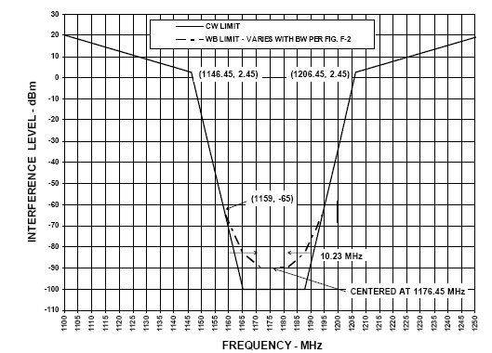
- GPS L5 Continuous Interference Level at the Antenna Port

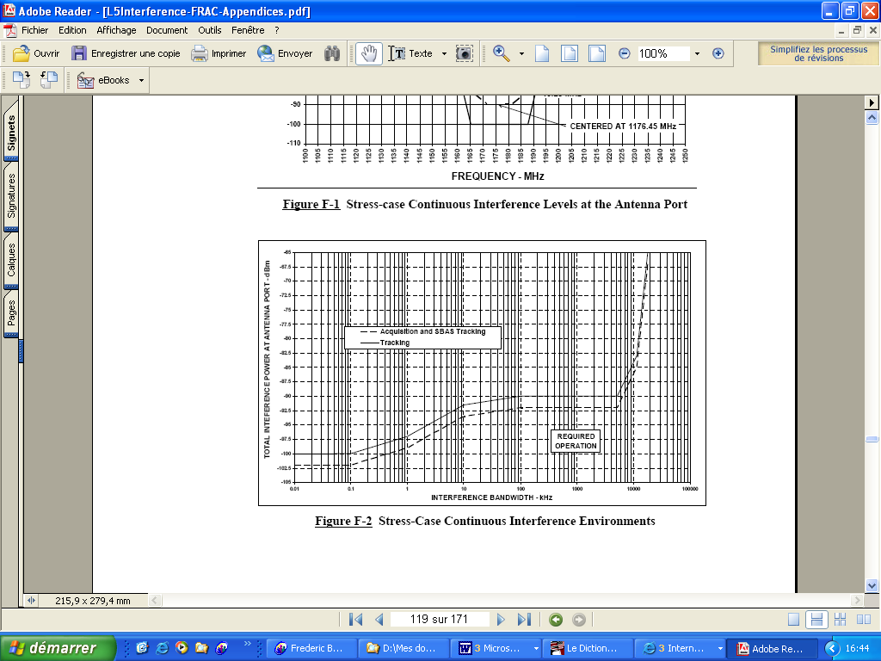
- GPS L5 Continuous Interference Environment

The lower mask of Figure 3 relates to continuous CW interference. On the other hand, the upper mask for frequencies in between 1176.45 MHz +/- 15 MHz relates to interference levels specified in Figure 4 for interference bandwidths between 100 and 15.000 kHz. For bandwidths outside of that range, the level of the mask in Figure 3 is adjusted up or down according to the levels of Figure 4. For example, for the upper curve of Figure 4, interference with a bandwidth of 22.7 MHz raises the mask at 1176.45 MHz at a level of –83 dBm. Moreover, if the center of the interference moves away from 1176.45 MHz, the levels of Figure 4 are raised according to the mask of Figure 3. For instance, for the upper curve of Figure 4, for interference centered at 1159 MHz, the curve of Figure 4 is increased by 22.5 dB.

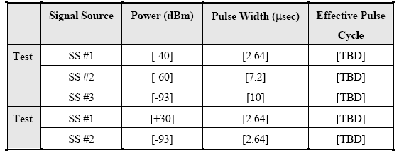
- Table 2: GPS L5 Pulsed Interference Environment

Note: Pulse widths defined in Table 5 are intended to cover DME- and JTIDS-like interference. The GPS L5 receiver is required to operate with the specified pulsed interference in the in-band and near-band frequency range. Values in square brackets need to be consolidated and effective pulse cycle values are still to be determined.

- EUROCAE WG 62 Proposed Baseline for Galileo E5a/E5b Susceptibility

Military Systems
Two military systems operate in the 960-1215 MHz frequency band: the TACAN and the JTIDS/MIDS (Link 16) systems. When these military systems are implemented in a country, compatibility with civil systems is negotiated on a national basis.

TACtical Air Navigation (TACAN) System
The TACAN system was designed primarily for military use. A TACAN ground station consists of a DME transponder and an associated rotating antenna. This antenna rotates at 900 revolutions per minutes enabling an aircraft to estimate its bearing with respect to the ground station. Ranging information is also estimated by the airborne TACAN receiver thanks to the DME transponder. This system operates on the same frequencies and with the same channel separations than those of DME (see Figure 2). Since the TACAN system principle is essentially the same than that of the DME, its relevant characteristics are assumed to be the same (see Table 1).

JTIDS/MIDS
The Joint Tactical Information Distribution System / Multifunctional Information Distribution System (JTIDS/MIDS), a.k.a. Link-16, is an advanced radio system that provides information distribution, position location and identification capabilities in an integrated form for military operations.

JTIDS/MIDS has no internationally recognized status in the ARNS band. Operational constraints are set on national basis to avoid interference with existing air traffic control equipment that operate within the same frequency band (e.g. DME and SSR).

It is a spread-spectrum frequency hopping system that operates in the 960-1215 MHz frequency band via a time-division multiple-access (TDMA) time slot structure and defined communications nets. Link-16 terminals can participate in 128 time slots per second. Each time slot lasts 7.8125 ms and contains either 72, 258 or 444 pulses depending on the message structure. Each pulse lasts 13 μs with a 6.4 μs active level and a 6.6 μs passive level which includes a rising time of 1 μs. Pulses consist of 32 contiguous 200 ns chips and are uniformly separated by a 13 μs symbol structure.

The transmission frequency changes randomly between two consecutive pulses and there is a set of 51 authorized carrier frequencies as depicted in Figure 6. The carrier frequencies are spaced at 3 MHz intervals except in the two exclusion bands, centered at 1030 MHz and 1090 MHz, which protect SSR. Future Link 16 equipment will have the capability to change the number of frequencies used to less than 51 but no less than 37.

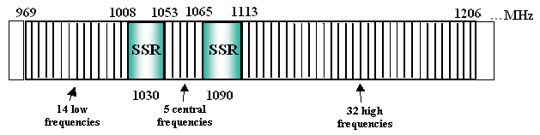
- The 51 JTIDS/MIDS Hopping Frequencies

For the time being, no relevant characteristics of JTIDS/MIDS terminals were found. Further investigations are required.

Summary
Known susceptibilities that were presented in previous sections are summarized and classified in Table 6. Interference are classified under pulsed and continuous. Regarding pulsed interference, signals are further classified under DME-, JTIDS- and SSR-type. The corresponding pulse durations and duty factors are indicated in previous sections of this paper. When it comes to continuous interference, signals are classified under continuous wave (CW) and wideband.

Interference Type |  | DME |  | SSR |  | UAT |  | Galileo E5 | GPS L5 | JTIDS  /MIDS
 |  | A | G | A | G | A | G | Galileo E5 | GPS L5 | JTIDS  /MIDS
PULSED | DME-type | X |  | X |  | X |  | X ⁽¹⁾ | X ⁽²⁾
PULSED | JTIDS-type | X | X | X | X |  |  | X ⁽¹⁾ | X ⁽²⁾
PULSED | SSR-type |  |  | X
CONT. | CW | X | X |  |  |  |  | X ⁽¹⁾ | X
CONT. | Wideband | X |  |  |  |  |  | X | X
- Classification of Known Susceptibilities
⁽¹⁾ the corresponding values are still to be determined by EUROCAE WG 62
⁽²⁾ the corresponding values are still to be either confirmed or determined by RTCA SC-159 WG 6

Note: (A) and (G) denote respectively airborne and ground equipment.

Initial Compatibility Analysis
The new aeronautical communication system is designed to allow data transmissions between aircrafts and ground stations in both directions. Multiple candidate technologies were proposed and compared by EUROCONTROL in [8] and by FAA in [9]. In the selection process of the most adequate technology, demonstration of the electromagnetic compatibility with other operating systems is a key point. The level of unwanted emissions from the FCS, spurious and out-of-band, should be compliant with susceptibilities provided in Section 1 of this paper as well with potential additional susceptibilities.

In the scope of this paper, we focus on the band between 960 and 977 MHz for the introduction of the FCS. This band is voluntary chosen right below the UAT frequency and in a band where DME frequency allocations are defined on a national basis and are not part of the ICAO DME channel plan so that their use is scarce. Some states also use the 960-977 MHz band for military mobile TACAN allocations. Thus, most of the compatibility study will have to be performed for adjacent-band systems except for potential national allocations to DME between 962 MHz and 977 MHz and military TACAN allocations between 960 MHz and 977 MHz. In the latter case, co-channel compatibility needs to be verified.

This section presents a high-level compatibility analysis; the technical work is still to be undertaken. First of all, the various interference scenarios to consider are indicated. Then the susceptibility values given in Section 1 are analyzed as regards the compatibility study of the FCS.

Interference Scenarios to Consider
To perform the compatibility analysis, one can use the classic “source-path-receiver” methodology. It requires to collect information on those three following elements:
  - Potential interference sources (location, antenna characteristics, transmitted power, operating frequency, waveform type etc…). In our study, the potential interference source is the FCS.
  - Interference-victim receiver encounter scenario (distance between interference and victim receiver antenna, victim receiver antenna characteristics etc…).
  - Receiver performance in presence of interference (susceptibility values depending on the interference type).

Once those information are available, link analyses can be performed. There are multiple potential outcomes of these analyses, e.g. the maximum allowable unwanted emissions by a potential interference source or the minimum separation distances between the interference source and the victim receiver.

The compatibility scenarios that must be analyzed are listed below. For each of them, the “source-path-receiver “ methodology may be applied.

- Co-Site compatibility. FCS transmissions from an aircraft will be sensed by aeronautical receivers onboard the same aircraft such as DME interrogator, SSR transponder and UAT transceiver. Co-site compatibility is likely to be one of the driving compatibilities given the close spatial proximity of equipments and the close frequency proximity of systems, such as DME X-mode and UAT, and the considered band for the FCS.
- Air-to-Ground compatibility. FCS transmissions from aircrafts will be sensed by aeronautical ground stations such as DME transponder, SSR interrogator and UAT ground stationt. In a worst-case approach, minimum separation distances between the aircraft and ground-based stations must be assumed. These minimum distances depend on the current phase of flight of the aircraft. For instance, for en-route, aircrafts are constrained to be at an altitude of at least 500 feet and 1000 feet above structures or terrain in un-congested and congested areas, respectively.
- Ground-to-Ground compatibility. Uplink transmissions from FCS ground stations will be sensed by aeronautical ground stations such as DME transponder, SSR interrogator and UAT ground station. One of the outcomes of this item will be the minimum separation distance between the involved ground stations.
- Ground-to-Air compatibility. Uplink transmissions from FCS ground stations will be sensed by airborne aeronautical receivers such as DME interrogator, SSR transponder and UAT transceiver. Same comments than for the Air-to-Ground compatibility.
- Air-to-Air compatibility. FCS transmissions from aircraft will be sensed by aeronautical receivers onboard a nearby aircraft such as DME interrogator, SSR transponder and UAT transceiver. For this case, minimum separation distances are given by applicable ATC standards which are 1000 feet and 3 NM in vertical and horizontal directions, respectively.

Analysis of Known Susceptibilities
Section 1 of this paper listed the known susceptibilities of systems operating in the 960-1215 MHz ARNS frequency band. Depending on the characteristics of the investigated technology, some of those susceptibilities will be relevant for the compatibility analysis. On the other hand, some susceptibility values will be missing and so will have to be determined.

Temporally speaking, one has to distinguish between continuous and bursted-type communication signals, e.g. TDMA structure. Then, from a frequency standpoint, narrow band and wideband signals must be considered separately. Wideband signals are assumed to be signals whose spectrum is flat over the victim receiver passband.

The emissions of the FCS in adjacent bands will consist of out-of-band emissions and spurious emissions such as intermodulation products. Note the FCS cannot generate any harmonics within the 960-1215 MHz frequency band given the small frequency separation between the involved systems. Assuming the FCS equipment transmit on multiple frequencies, intermodulation products will have to be considered.

Continuous Signal
If FCS equipments broadcast continuous signals, like for W-CDMA, then out-of-band emissions will result in an increase of wideband background noise in passbands of victim receivers. Then, the allowable out-of-band emissions can be inferred from wideband continuous susceptibilities indicated in Section 1. From Table 6, one can see wideband susceptibility values are missing for ground DME transponder, both airborne and on-ground SSR equipments, both airborne and on-ground UAT equipment and JTIDS/MIDS terminals.
Regarding co-channel compatibility, if the spectrum of the FCS is large as compared to the victim receiver passband (e.g. 6 MHz for DME equipment) then continuous wideband susceptibilities may be applicable. Otherwise, dedicated study through simulations or experiments may be required.

Bursted-Type Signal
Assuming the FCS employs a TDMA structure, victim receivers may consequently receive burst-type interfering signals. For adjacent-band compatibility, out-of-band emissions will consist of bursts of background noise within the receiver passband. Typical bursts durations range from about hundreds of microseconds to a few milliseconds. Durations cannot be too small in order to transmit enough data. For instance, burst durations equate 276 μs for short UAT ADS-B messages, 577 μs for GSM and 13.3 ms, at the minimum, for VDL Mode 4. Unfortunately, the susceptibility figures listed in Section 1 concern very short pulses lasting, at the maximum, a few microseconds (i.e. 6.4 μs for Link 16 pulse). Thus none of the values provided in Section 1 seems to be applicable in this case.

Moreover, because of the rise and fall times of burts, time-domain transient peaks are expected within the victim receivers passbands. Those transient peaks must be accounted for as they may be harmful to receivers. For instance they could lead to early RF component saturation.

When it comes to co-channel compatibility, potentially with DME or TACAN equipment, none of the susceptibility values specified in Section 1 are likely to be valid. Again, the reason is that FCS bursts will last very likely much longer than DME or JTIDS pulses. As in the continuous case, dedicated analysis to determine adequate susceptibility values may be required.

Missing Susceptibilities Assessment
The two previous sections pointed out the missing susceptibilities to conduct a complete compatibility analysis of the FCS with aeronautical systems operating in the 960-1215 MHz ARNS frequency band. Analytical derivation of those susceptibilities is not an easy task and may become cumbersome. Instead it would be possible to either set up experiments or run computer-based simulations.

For instance, assuming several modulation schemes (e.g. QPSK and CPFSK) and different access techniques (e.g. TDMA and CDMA), a signal generator could be used to generate temporally the FCS. Then the most prevalent models of the concerned aeronautical equipments (e.g. Rockwell Collins DME-900 interrogator for DME) could be tested in presence of such FCS signals. Criteria to determine susceptibilities are indicated in tables of Section 1. For instance, the ground DME beacon susceptibility determination is based on its reply efficiency that must equate, at least, 70%.

Note this paper does not cover systems operating below the 960-1215 MHz ARNS band such as the GSM 900 system (880-915 MHz uplink and 935-960 MHz downlink). The susceptibilities of such systems should also be analyzed.

Interference Reduction
There are multiple ways to reduce the impact of the future aeronautical communication system on other systems. The main ones are listed below:

Signal Spectrum Design
The spectrum of the signal can be carefully selected so as to limit the occupied bandwidth to the most efficient value as well as to limit the level of the components emitted in the outer parts of the spectrum, i.e. unwanted emissions. To do so, recommendation ITU-R SM.328-10 will be useful. For instance, nulls of the spectrum may be chosen on the UAT and DME equipment frequencies. An interesting modulation is the binary Continuous Phase Frequency Shift Keying (CPFSK) that is implemented by both the Link 16 (JTIDS/MIDS) and the future UAT datalink. This CPFSK modulation reduces the level of sidelobes as well as constraints the passband.

Emission Filter
The emission filter should also be chosen carefully to limit the amplitudes of spectrum components present in outer parts of the spectrum. Regarding spurious emissions, recommendation ITU-R SM.329-9 should be applied. Technology state-of-the-art and economic constraints should also be accounted for when selecting the emission filter.

Signal Polarization
The signal polarization may be chosen to include, if possible, polarization losses at the other systems receiver antennas level.

Antennas Isolation
The on-board isolation between the FCS and other systems antennas should be carefully studied. Indeed, it will allow reduction of unwanted emission levels in victim receivers passbands. Typical isolation value is 40 dB for on-board aeronautical systems.

Mutual Suppression System
If deemed necessary, the FCS may be connected onboard to a mutual suppression system in order to prevent mutual interference with other systems. However, the operational impact of the disruption of critical data transmission by the FCS, such as ATC data, should be further assessed.

Conclusions
It is recommended to the Working Group:

- To note the results of the analysis of the known susceptibilities of aeronautical systems operating in the 960-1215 MHz ARNS frequency band presented in this paper;
- To note the potential lack of some susceptibilities data to prove compatibility of a possible FCS operating in the 960-1215 MHz ARNS band; and
- To provide guidance and recommendations on the ways forward for this compatibility analysis.

References

[1] ICAO, Aeronautical Communication Panel, WGW, Appendix A to the 1st meeting report, ICAO Position for ITU WRC-07

[2] ICAO, July 2002, Fifth Edition, Annex 10 to the Convention on International Civil Aviation – Aeronautical Telecommunications – Volume I – Radio Navigation Aids

[3] ICAO, July 2002, Third Edition, Annex 10 to the Convention on International Civil Aviation – Aeronautical Telecommunications – Volume IV – Surveillance Radar and Collision Avoidance Systems

[4] EUROCAE, Jan. 2003, Minimum Operational Performance Specification for Secondary Surveillance Radar Mode S Transponders – ED-73B

[5] ICAO, Nov. 2004, Implementation Manual for the Universal Access Transceiver (UAT), Revision 1.0

[6] EUROCAE WG 62, July 2005, Interim MOPS for Galileo Civil Aviation Receiver

[7] RTCA SC-159, Sept. 2004, Assessment of Radio Frequency Interference Relevant to the GNSS L5/E5A Frequency Band

[8] EUROCONTROL, Dec. 2004, Draft Future Communication Study – Technology Pre-Screening

[9] NASA, May 2005, Technology Assessment for the Future Aeronautical Communications System

