 | International Civil Aviation Organization  WORKING PAPER
  IAVWOPSG/4-WP/45
  28/8/08
INTERNATIONAL AIRWAYS VOLCANO WATCH OPERATIONS GROUP (IAVWOPSG)

FOURTH MEETING

Paris, France, 15 to 19 September 2008

Agenda Item | 6: | Development of the IAVW
 | 6.2: | Development of future satellite sensors and other systems to improve detection of volcanic eruptions and VA clouds

INSTALLATION OF A WEATHER RADAR IN ICELAND TO DETECT VOLCANIC ASH

(Presented by the Secretary)

SUMMARY
This working paper refers to the planned installation of a weather radar in East Iceland to improve detection of volcanic ash.

- INTRODUCTION
  - The group may be pleased to note that the Secretariat received information from the Icelandic Meteorological Office (IMO) related to the planned installation of a weather radar in East Iceland for better coverage in detecting volcanic ash in case of eruptions in that part of the country. It should be noted that IMO plans to send a formal request to the ICAO Committee on Joint Support of Air Navigation Services for financial support for purchase and installation of weather radar in East Iceland to improve the detection and monitoring of volcanic ash plumes related to volcanic eruptions in the area. Additionally, the group may note that this issue was informally referred to the Secretariat who advised IMO to send a proposal for discussion at the IAVWOPSG/4 Meeting.
- ACTION BY THE IAVWOPSG
  - The IAVWOPSG is invited to review the information received from IMO, included in the appendix to this paper, and express its technical view about the convenience of this proposal
— — — — — — — —

IAVWOPSG/4-WP/45
Appendix

APPENDIX

A Weather radar in East-Iceland to detect volcanic ash

A petition to the INTERNATIONAL AIRWAYS VOLCANO WATCH OPERATIONS
GROUP ,IAVWOPSG 4, for reaction and statement

The Icelandic Meteorological Office (IMO) plans to send a formal request to the ICAO Joint Support Committee, JSC, of the Den-Ice Agreement for financial support for purchase and installation of a weather radar in East Iceland. This will improve the detection and monitoring of volcanic ash plumes related to volcanic eruptions in the area. IMO asks the IAVWOPSG 4 meeting to react on this planned proposal, but IMO believes that IAVWOPSG opinion will be decisive for the outcome of the request within the JSC.

Following text indicates the importance of a weather radar to track and monitor volcanic ash plumes and argues for the need to improve the detection by adding radar in eastern-part of Iceland. If this will be performed, it will result in more accurate information about the start of volcanic eruptions, the plume height, its density and distribution of the ash in the most important early stage of an eruption. IMO believes this will lead to improved input data into the trajectory and dispersion models resulting in improved output information of an area affected by the ash in the atmosphere. This will further improve the confidence in the model results.

Volcanic eruptions in Iceland pose a major hazard to the traffic of jet aircraft in the sub polar North Atlantic-Arctic regions and beyond as volcanic ash clouds can travel far away from its origin. Thus, there is an urgent need to improve the capability of measuring and tracking volcanic clouds from Iceland. This can be done by using weather radar and in addition satellite remote sensing and other observaions. The active volcanoes in Iceland are in many cases remotely located and in addition during winter months, due to extended periods of darkness, visible ash detection is limited. Therefore IMO regards the use of radar as vital for precise information and forecasts of the dispersion of the ash. Hence, near-real-time monitoring of volcanic clouds can be achieved from the radar providing invaluable information for relevant meteorological centres and aviation authorities (e.g. Icelandic Meteorological Office, ISAVIA (responsible for the Icelandic ATM service provision and airport operations), Air Traffic Control Centres, and London, Toulouse and Montreal Volcanic Ash Advisory Centres).

In Iceland there is, per today, one C-band weather radar located near the international airport in Keflavík. This radar has shown to be able to locate and monitor volcanic clouds from eruptions in Iceland as mentioned above (see Lacasse et al., 2004). For volcanoes, located within 150 km of the radar (e.g. Mt Hekla), eruption column rise can theoretically be detected within a few minutes of the eruption onset, thereby providing one of the most crucial information for forecasting models: the eruption onset time and information about the plume height. However, present radar at Keflavik Airport can only monitor a limited number of active volcanic systems in South-West Iceland, e.g. Hekla, Tindfjallajökull, Eyjafjallajökull, and Vestmannaeyjar (Heimaey) (see Figure 1, Appendix I). Several of these volcanoes are potential sources of subplinian and plinian eruption columns, reaching high in the atmosphere. Eruption plumes from volcanoes located in the East an North East of Iceland e.g. Grímsvötn in Vatnajökull, Öræfajökull, Askja and Krafla, will not be adequately detected by the Keflavik radar (see Figure 1, Appendix I). Grímsvötn which is located at Vatnajökull glacier is one of the most active volcanoes in Iceland, erupted last the 1st to the 7th of November 2004. Studies indicate that Grímsvötn are entering an active state with eruption period of every two to seven years.

The lowest height of a volcanic plume, located 150 km away from the Keflavik radar´s is about 2 km height and the lowest height of a plume, located about 240 km away (the distance from the radar to Grímsvötn) is about 6 km height. The lowest detection limit of the radar to Mt Krafla, located in the northeast of Iceland is 9 km height. This is of course unacceptable in detecting ash plume in its first stage and is not at all sufficient. In addition to the lower detection limit of the radar mentioned above, the accuracy of the height of the plume decreases with increased distance from the radar location to the volcanic plume.

A weather radar proves to be one of the most valuable and cost-effective tools for the meteorological agencies and aviation authorities in terms of preventing encounters of hazardous volcanic particles with aircrafts. To improve the monitoring of volcanic clouds in Iceland, IMO regards important to install radar in the eastern part of the country. In fact for full coverage three additional radars are needed to encompass the eastern, northern and south-eastern flight sectors over Iceland. However, the priority is to install a radar in the eastern part due to the fact that majority of active volcanoes are located in that region.

The Icelandic Meteorological Office asks the IAVWOPSG 4 meeting for a reaction and statement to its planned proposal to ICAO JFC regarding additional radar in Iceland to improve the detection, monitoring and tracking of volcanic ash plumes in Iceland and to improve the values of the input data into the forecasting models of the drift and distribution of volcanic ash clouds.

Reference

Lacasse, C., Karlsdóttir, S., Larsen, G., Soosalu, H., Rose, W.I., Ernst,
G.G.J., Weather radar observations of the Hekla 2000 eruption cloud, Iceland.
Bull. Volcanol. 66, pp. 457-473, 2004.

Appendix I

Here three images are shown to illustrate the detection and the detection limitations of the C-band weather radar at Keflavik airport in Iceland.

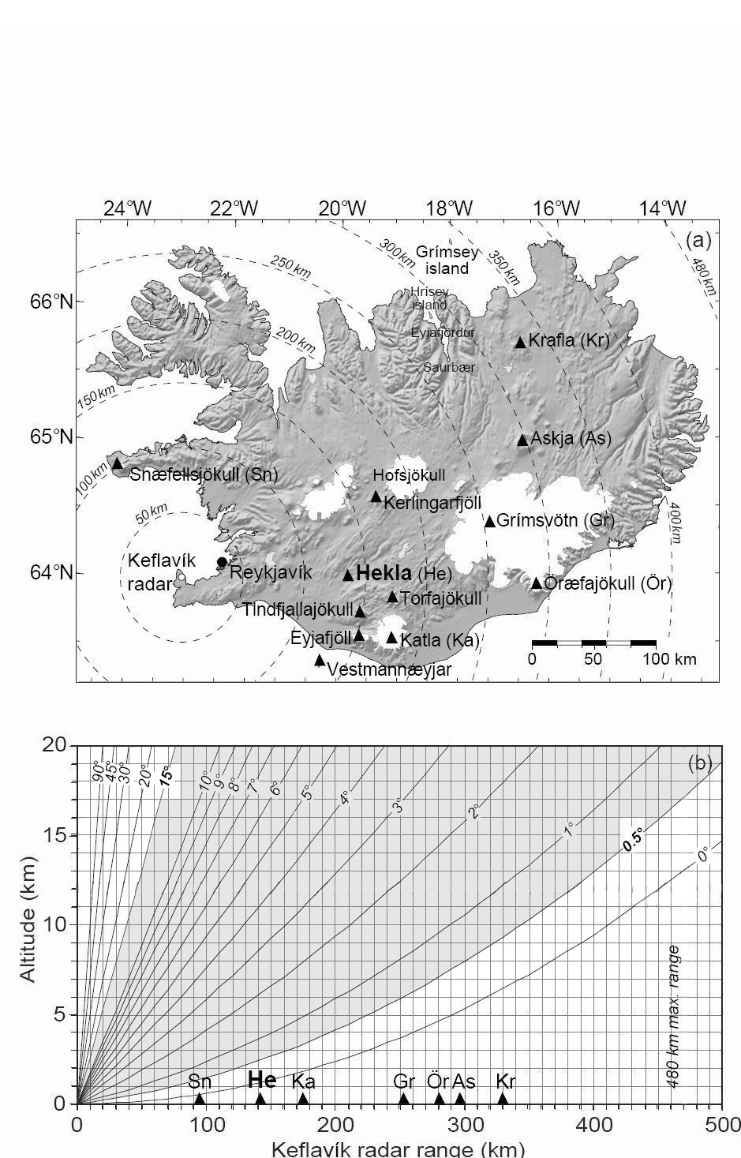
Figure 1 shows the location of the radar and the distance to the different volcanic active regions in Iceland (a) and the detection limit of the radar to the plumes from the different volcanoes (b).

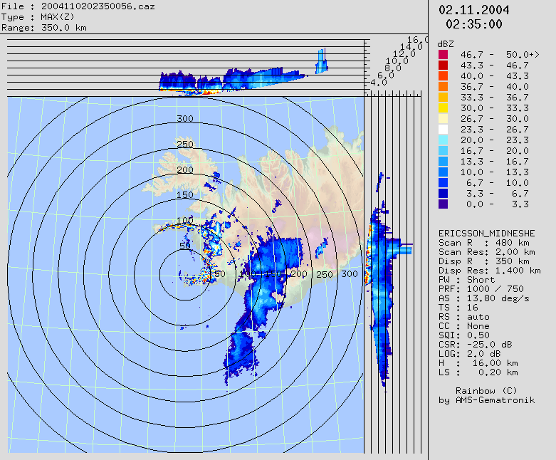

Figure 2 shows a radar image from the Grímvötn eruption in November 2004. In the upper bar the height of the volcanic plume is shown and the detection limit of the radar is clearly seen.

— END —

