Exercices
Generate a RCR for the following cases. Specify the means of communication of the RCR. Explain how the ATC should communicate the RCR to pilots from each threshold.
Case 1
- Diass Blaise Diagne International Airport (GOBD), Dakar, Senegal, Runway 01/19
- 23 July 2018 at 11:33 AM UTC
- A thunderstorm is passing and significant rain is falling on the airport and surrounding region
- The runway is completely covered with a layer of water that is approximately I cm in depth
- The outside air temperature is 26°C

Case 2
- Runway 04/22 at Roberts International Airport (GLRB), Monrovia, Liberia
- 17 June 2019 at 04:15 PM UTC
- A significant rain has fallen on the airport and surrounding region
- The first runway third of the runway has 33% coverage of water up to 3 mm
- The second runway third has of the runway has 20% of water up to 3 mm
- The last third has of the runway has 50% of water up to 3 mm

Case 3
- Runway 03/21 at Leon-Mba International Airport (FOOL), Libreville, Gabon
- 04 October 2018 at 10:20 AM UTC
- The runway is covered by rubber deposits
- It has rained recently. The runway is still covered with visible dampness 3 mm deep
- Out of experience the runway inspector knows that the places where landing aircraft touch ground are slippery in such conditions

Case 4
- Runway 06/24 at Ndjili International Airport (FZAA), Kinshasa, D. R. of Congo
- 18 April 2019 at 09:20 PM UTC
- A rain has fallen on the airport and surrounding region
- The first runway third of the runway has 9% coverage of water up to 3 mm
- The second runway third has of the runway has 27% of water up to 3 mm
- The last third has of the runway has 15% of water up to 3 mm

Case 5
- Runway 03/21 at Kotoka International Airport (DGAA), Accra, Ghana
- A rain is falling on the airport and surrounding region
- The runway surface is covered by water up to 3 mm depth
- Declared distances
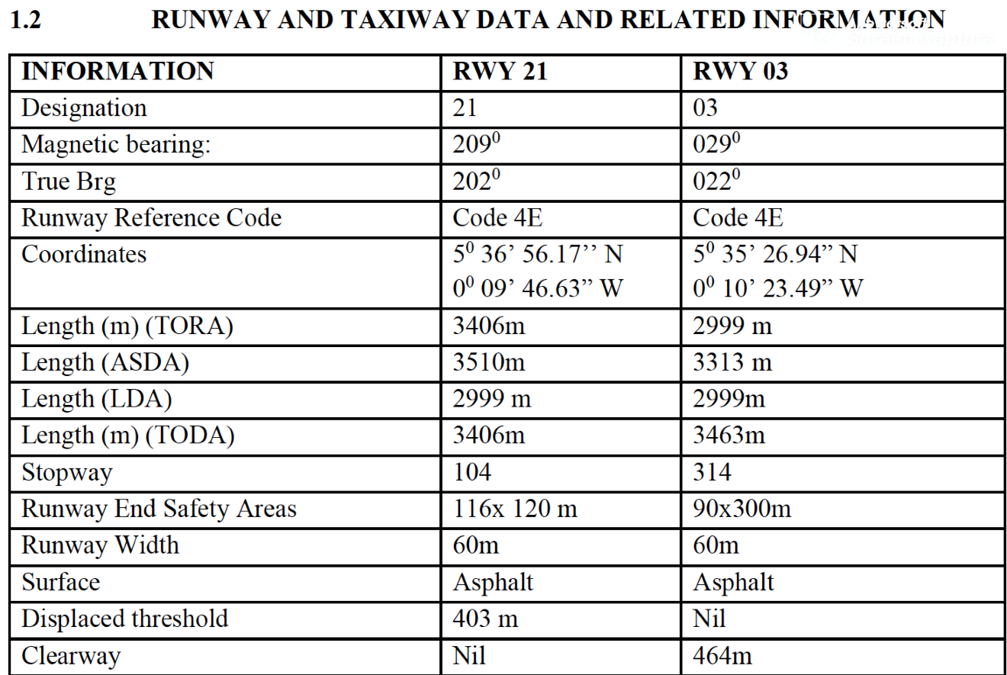
- Define the length of each runway third from the two thresholds and generate the RCR

Case 6
- Runway 03/21 at Kotoka International Airport (DGAA), Accra, Ghana
- A rain is still falling on the airport and surrounding region
- A pilot report to the ATC a runway braking action of MEDIUM TO POOR
- Which actions should be taken?
- A new assessment revealed that the first and last runway thirds are covered by 3 mm of water and the second runway third by 5mm of water
- Which action will be taken?

