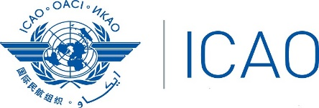
INTERNATIONAL CIVIL AVIATION ORGANIZATION
WESTERN AND CENTRAL AFRICAN OFFICE
Twenty-Seventh Meeting of the AFI Satellite Network Management Committee (SNMC/28)

(Abuja, Nigeria, 06-10 May 2024)

Registration Form

(Kindly fill and return to icaowacaf@icao.int and sarmah@icao.int with copy to ogajibo@gmail.com, jokpanachi@nama.gov.ng, hsuleiman@nama.gov.ng and to kayolawale@gmail.com; osunmonu@nama.gov.ng)

First Name (in full)

Family Name (in full)
Title

State
Organization
Status Member/Observer
Address

Telephone/Fax ___________________________________________________________
E-Mail
Hotel in Abuja

