RBS COVID-19 Modifier
Using iSTARS Risk Based Surveillance (RBS) App for COVID-19 Contingency
A safety risk-based surveillance approach enables States to prioritize and allocate their safety management resources for surveillance activities based on the safety risk profile of each AOC holder. The following contains guidance and recommended steps for using the iSTARS RBS application along with additional criteria regarding COVID-19 for States to take into considerations. The States may need to customize this “modifier” to suit their individual circumstances.
- Login to the App and proceed to the SAFETY PERFORMANCE section.
- Carefully read the guidance on how to assess each question, by clicking the information icon .
- Complete the OPERATIONAL COMPLEXITY section using data obtained before the COVID-19 crisis.
- On the SCHEDULE section, the population size should be adjusted according to current scope of operations (current number of in-service aircraft, currently served destinations (stations) and check pilots). A suggested surveillance schedule would be generated as shown below:
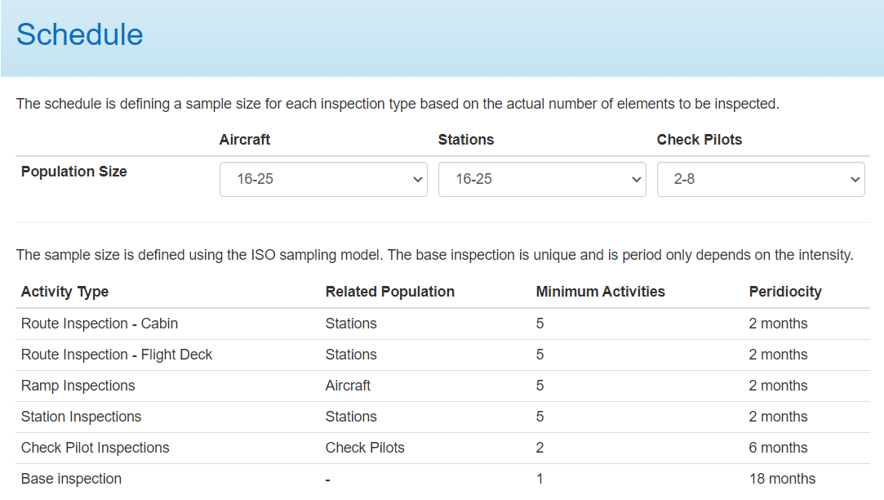
Sample

- This suggested surveillance schedule provides the minimum number of inspection activities (for route, ramp, station, etc.) along with suggested periodicity (suggested interval between consecutive inspection activities), which should be completed. In the sample figure above, it implies that the following inspections are needed: 5 “Route Inspections – Cabin”, 5 “Route inspections – Flight Deck”, 5 “Ramp inspections”, 5 “Stations inspections” and 2 “Check-pilot inspection” in the following 12 months, plus 1 Base inspection in the following 18 months.
- Adjust the schedule based on impacts and changes as a result of COVID-19:
  - Complete the “COVID-19 Impact Checklist for AOC Holders”(see the appendix of this document);
  - Upon obtaining the score, use the table below to adjust the surveillance considering the outcome of the “COVID-19 Impact Checklist for AOC Holders”.
Score | Adjustment to the number of surveillance activities for all types*
36-45 | No adjustment needed
28-35 | Increase surveillance by 20%
19-27 | Increase surveillance by 50%
9-18 | Increase surveillance by 100%
* Please see the sample given below paragraph 4.

- An adjusted surveillance schedule factoring the impact of COVID-19 will be obtained following the steps mentioned above. Given the on-going changes, the surveillance schedule should be recalculated, at the minimum, every 3 months per AOC holder.
- Considering the requirements and recommendations from the Public Health Authorities on mandatory physical distancing and travel restrictions that make on-site surveillance activities difficult or impossible, CAA inspectors may need to adopt alternate means (remote interviews, remote audits, desktop reviews, delegation, etc.) to adhere to or modify the surveillance schedule.

Appendix
COVID-19 Impact Checklist for AOC Holders
Notice: This checklist aims to assist operational and maintenance inspectors of the State of the Operator with assessing the risk profile of an air operator affected by COVID-19. Please respond to each statement indicating your level of agreement/disagreement based on information or evidence collected by various surveillance activities such as conduct of on-site inspections (announced and unannounced visits), the review of documents submitted by the AOC holder, meetings with concerned parties and analyses of available safety information, remote and desktop surveillance activities. CAA can customize this checklist with the subject matter expert before utilization.
 | Strongly Disagree  1 | Disagree  2 | Neither agree nor disagree  3 | Agree  4 | Strongly Agree  5 | N/A  5
- The operator's availability of competent personnel and resulting capacity to provide services has not been influenced by COVID-19.
- The operator has sufficient personnel including crew, operation control personnel, maintenance personnel, ground handling personnel etc., for operation contingency.
- The operator has implemented programmes to maintain operation personnel’s competencies at an equivalent level to pre-COVID-19, using effective measures and quality assurance.
- The operator continuously monitors, documents and evaluates its availability of competent personnel and resulting capacity to provide services on a regular basis.
- The operator's safety risk management measure(s) regarding transportation of cargo in passenger cabin (TCPC) are effective. If the operator does not transport cargo in passenger cabin, please select N/A.
- The operator’s TCPC operation complies with CAA’s regulations and requirement.
- The operator has assessed the operational and airworthiness risks regarding TCPC and implemented the corresponding mitigations.
- The operator has revised the related procedures and provided access to crew and other personnel.
- The operator has implemented training programmes for crew and other personnel to be qualified for TCPC operations.
- No non-compliance has been observed.
- The operator has implemented and documented measure(s) to address crew health management, while exemptions have been granted on medical assessment and medical certificate extension.
- The operator has implemented and documented measure(s) to monitor crew health status, while a medical examination is not available.
- The operator assures that remote consulting for health management is available to all operational personnel, which could be provided by health certified organizations for free or by specialised health service provider under contract.
- No occurrence related to medical incapacitation has been observed.
- The operator has implemented and documented measure(s) to address FRMS measures for special operation with temporary exemption on duty time limit.
- The operator has implemented and documented measure(s) to monitor crew fatigue status.
- The operator has implemented FRMS measures for special operation with temporary exemption on duty time limit.
- No incident citing crew fatigue as a contributing factor has been observed or no increase in the submission of crew fatigue reports has been recorded.
- The operator has implemented risk mitigations regarding granted exemptions.
- If the operator has been granted an exemption on a particular subject, its documented mitigations should be assessed to determine whether they meet State of the Operator’s requirements.
- The operator has documented all hazards and their associated risks introduced by existing exemptions, along with the respective mitigations.
- The operator has implemented quality assurance mechanism when alternative measures are taken on recurrent training, recency of experience, license proficiency check, operator proficiency check, etc.
- No non-compliance has been observed.
Note: Quick Reference Guides (QRGs) have been developed by ICAO in addressing COVID-19 related risks to the continuity of business and operations, while ensuring that the safety risks introduced by any changes from alleviations are also addressed. Please click here.
- The operator ensures the compliance with requirements regarding its operational and airworthiness responsibilities.
- The operator fulfills its operational and continuing airworthiness responsibilities, with consideration of alternative measures.
- If the AOC of the Operator allows the operator to perform maintenance without the need to hold a separate AMO approval, the ORP (operational risk profiling) result is satisfactory. Note: CAA can use or customize the risk-profiling tool for AMOs included in the iPACK.
- No occurrence related to the operator’s operational and continuing airworthiness responsibilities has been observed.
- The operator's availability of resources (in-house or contracted) to support ground handling has not been impacted.
- The operator regularly evaluates and documents its availability of resources (in-house or contracted) and take actions to ensure that ground-handling safety is not impacted.
- The operator can assure the available resources (in-house or contracted) to support ground handling activities such as preparation of aircraft to flight, reconfiguration and affecting mass and balance of the aircraft and disinfection of aircraft meet the need of operation contingency.
- No occurrence related to insufficient resource has been observed.
- The operator has implemented mitigating measures addressing the cumulative risk or compound effect of multiple exemptions
- The operator has also identified and documented the cumulative risk or compound effect of multiple exemptions, along with the respective mitigations.
- The operator keeps monitoring and documenting the implementation and the effectiveness of each mitigation.
- No occurrence related to exemptions has been observed.
- The operator has made the services of a psychological counselor available to all operation personnel, if any of them finds him/herself in the need of psychological counselling or considers it desirable.
- The operator has provided proof that its operation personnel have been provided access to the services of psychological counselor.
- The operator has provided proof that temporarily furloughed personnel will be provided the access to the services of psychological counselor before returning to their job duties.
Total Score

